IR Assignment-2

Made by- Archit Gupta (2010110126)

Deep Bera (2010110210)

No. of documents containing a term and its frequency in each document-



Normalized weight of each term in each document they occur in-



Normalized Tf-idf weight of all the terms in the query-

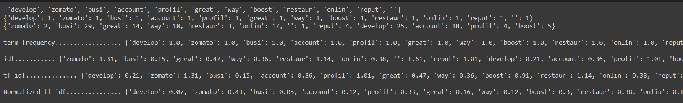

Cosine similarity between the query and all the documents respectively-

